
Dear Chris,

PHP POS and Vantiv Integrated Payments thank you for your business. We look forward to providing you with fast, affordable and secure payment processing, coupled with unmatched service and support for many years to come.

Below you will find important information needed to set up your account.

PHP POS Setup Instructions:
Hosted Checkout password generation:
- Log into Vantiv Integrated Payments, www.mercurypay.com, in the upper right hand corner, click “Login”
  - Sign in with your User ID (below) and password that you should have received in a separate email.
    - Your User ID is: chris@phppointofsale.com
- Select “Account Settings”
- Under “Hosted Checkout Password Management,” select the terminal for which you want to obtain a password and click “Continue.”
- Select “Generate Password”
- Copy and paste the Hosted Checkout Password to the Configuration Files in PHP POS.
- Be sure to click “Save” at the bottom after generating the Hosted Checkout Password.

Your online account will also be your portal to real-time access to your statements, transactions, customer care, technical support, account settings and tools. You can:
- See monthly statements (read “Decoding Your Statements” for more information)
- Review full transaction history
- View transaction batch totals by date, card type, and more!
- Check on transactions at one store or an entire chain
POS Configuration:
DBA Name | PHP Point Of Sale, LLC
Address | 6 Heron Way North
City, ST Zip | Fairport, NY 14450
Merchant ID #
Bank # (BIN)

PHP Point Of Sale, LLC can accept the following types of payment:
Visa |  | MasterCard |  | Discover |  | American Express
Diner’s Club |  | JCB

Hosted Checkout password generation:
You should have already been given authorization to access your merchant’s HostedCheckout password, please follow the steps below:

It is critical that before beginning to process, (1) the password is generated on MercuryView and (2) the password generated is copied and pasted to the Configuration Files for use by the merchant’s point of sale system.

If you ARE a Portal Administrator follow the steps below to generate the password. (If you ARE NOT a Portal Administrator see alternate instructions in section II).
- Log into https://portal.mercurypay.com/
- Select Account Settings
- Under HostedCheckout Password Management, select the terminal for which you want to obtain a password and click Continue.

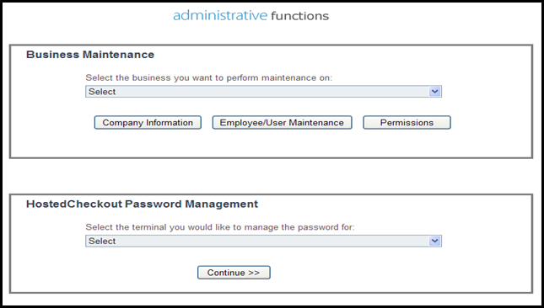
- Select Generate Password
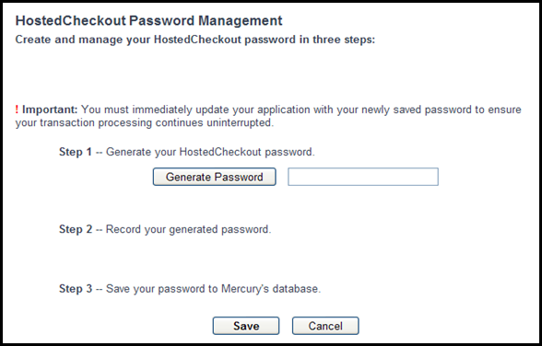

- Copy and paste the password to the Configuration Files for use by the merchant’s point of sale system.
- Select Save
**An email will be sent anytime a password is changed. This email will be sent to the Merchant Owner and the user who made the password change.
**Vantiv Integrated Payments recommends that the HostedCheckout password be changed every 90 days.
If you ARE NOT a Portal Administrator follow the steps below to generate the password.
- Log into https://portal.mercurypay.com/
- Select Account Settings
- Select the “Manage Mercury HostedCheckout Password” link
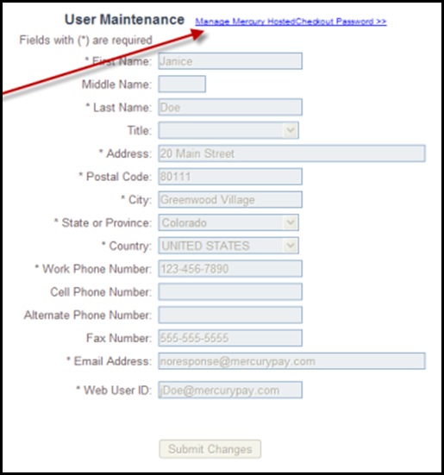

- Under HostedCheckout Password Management, select the terminal for which you want to obtain a password and click Continue.
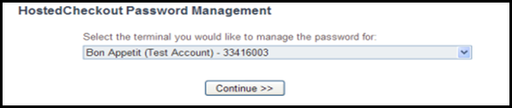

- Select Generate Password
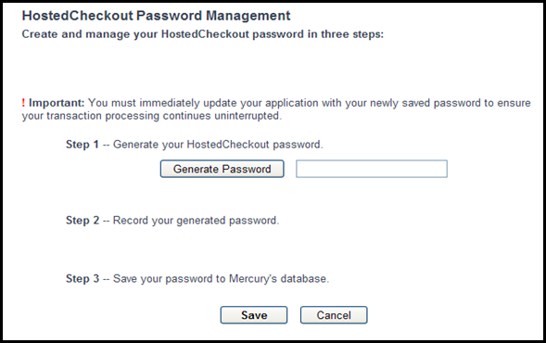

- Copy and paste the password to the Configuration Files for use by the merchant’s point of sale system.
- Select Save
**An email will be sent anytime a password is changed. This email will be sent to the Merchant Owner and the user who made the password change.

Log into PHP POS:

Step 1:
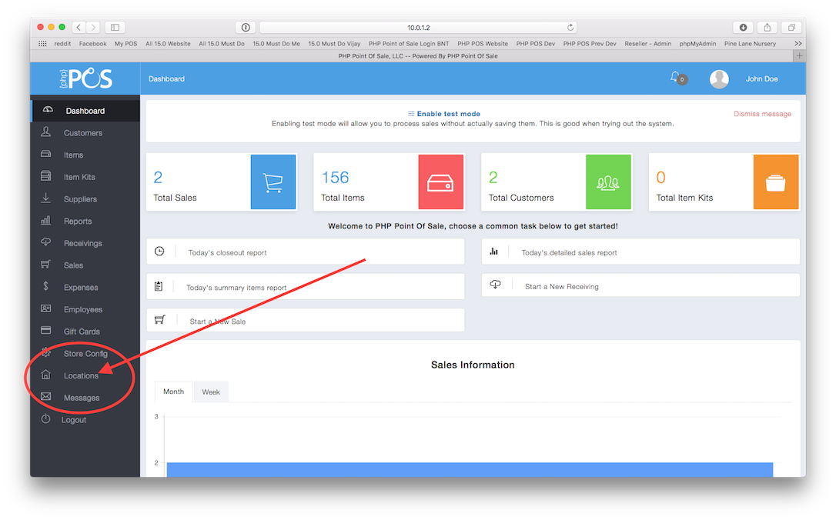

Step 2:
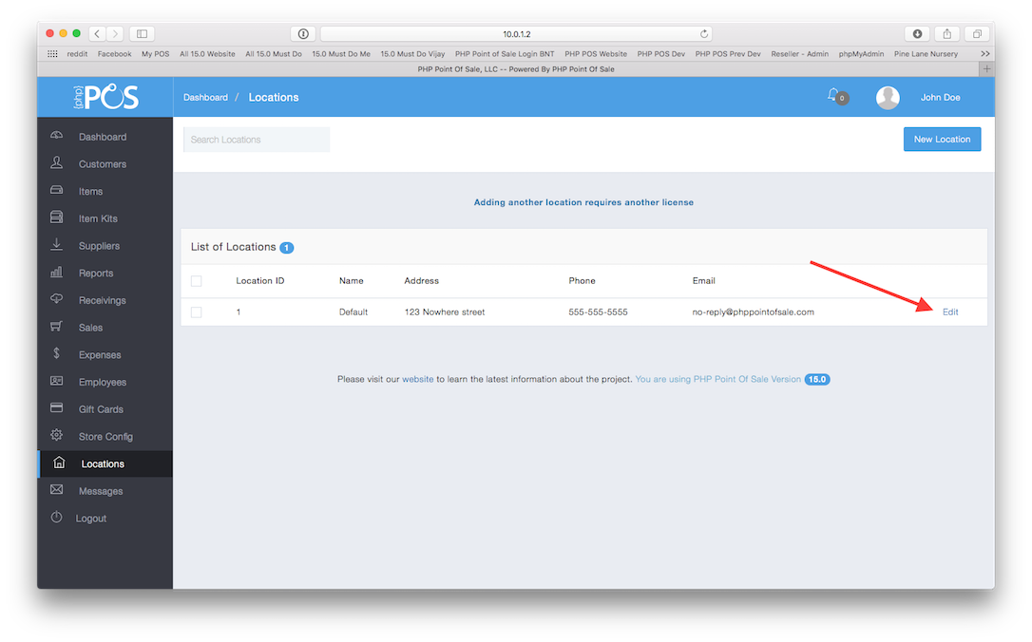

Step 3:
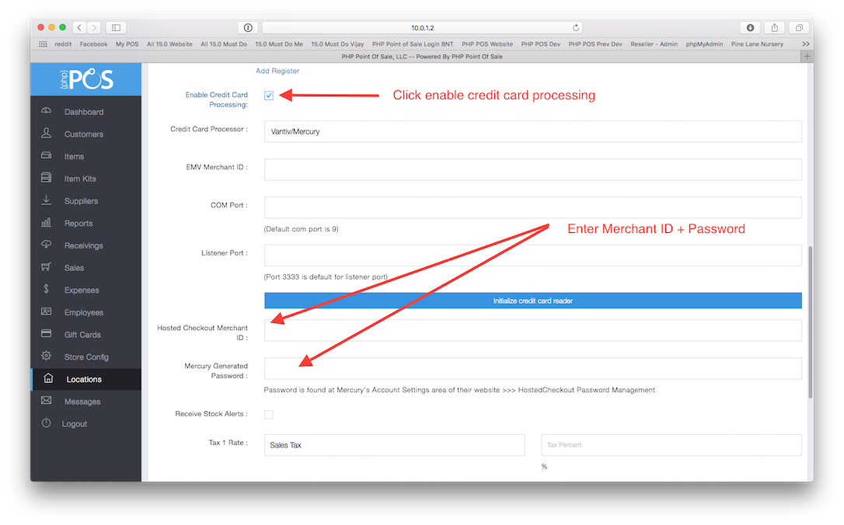

Click “Submit” and you are now ready to process credit card transactions!

**If your system supports multiple card acceptance devices (such as multiple lanes or workstations), you must configure each device with a unique identifier called “LaneID”.
Contact Vantiv Integrated Payments customer service and technical support team with questions or concerns. We are available 24 hours a day, 7 days a week, and 365 days a year!
- Phone: 800-846-4472 ext. 1818
- Email: ICS@vantiv.com
- Online live chat and technical support: https://www.mercurypay.com/mps_custportal

Contact PHP customer service at:
- support@phppointofsale.com

Check with your bank two or three days after you begin processing transactions to make sure your deposits are reaching your destination bank account. While this kind of problem is rare, it is prudent to ensure that deposits are reaching your intended account. If your checking account has a block to not accept debit requests from third parties, kindly provide your bank with the following Originator ID numbers:

WFBMPSACH1
WFBMPSACH2
WFBMPSACH3
4300604847
6300604847
5300604847
7300604847
5469221406

We also encourage you to view the Electronic Payment Card Acceptance Guide online at http://www.mercurypay.com/resources/electronicpaymentcardguide.pdf

Look for your Welcome Packet (Quick Reference Guide, Credit Card 101, and credit card decal stickers) to arrive in the mail in about a week.

